Mockup & HTML element planning
https://canva.link/fe7nsac4jpdku9y
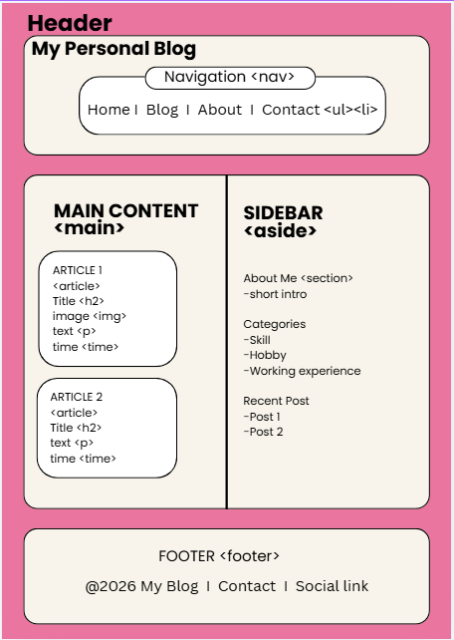

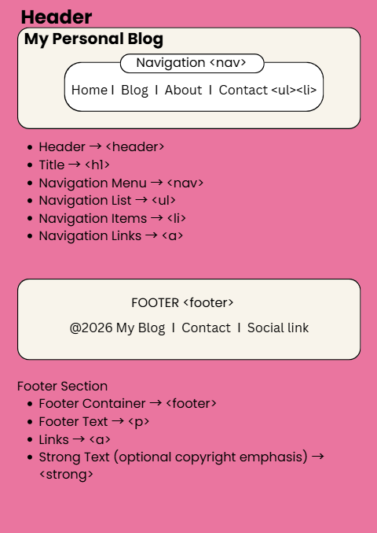
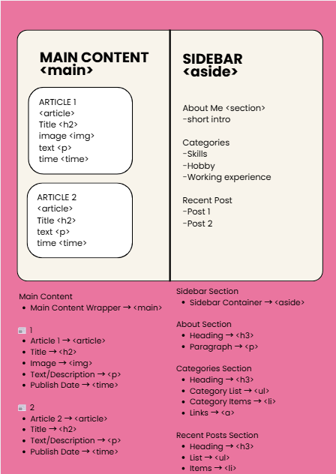

Reflection Report:
During this assignment, I felt most confident using basic HTML elements such as headings, paragraphs, and semantic tags like header, article, and footer. One challenge I faced was deciding how to properly structure the webpage using semantic HTML elements. Semantic HTML helped me organize my content in a clearer and more meaningful way, making the layout easier to understand. In my next HTML project, I would spend more time planning the structure before coding to improve efficiency and accuracy.

Checklist Report:
✔ Visual mockup included
✔ Complete HTML structure
✔ 10 semantic elements used
✔ Comments included
✔ Valid HTML syntax
✔ Reflection completed

